Willerby Carr Lane Primary School – Design and Technology
Topic: | Year: 4 | Strand: Electrical Systems

What should I already know?
- Used construction materials e.g. wood, card, and appropriate adhesives.
- Built simple series electric circuits and rectified faults that occur (Y4 Electricity science unit)
- The dangers of electricity and how to use it safely.
- Learnt how the components work and used simple tools required to connect these together

What will I know / be able to do by the end of the unit?
How are lights controlled? | - Lights are controlled by a switch.  - Types of switches are: on/ off switch, push to make switch, push to break switch, timer switch, tilt switch, rocker switch, slide switch, micro switch, timer switch, sensor switch.
How do switches work and how are circuits with a variety of different switches made? | - See electrical diagrams below.  - Create a variety of switches e.g. using paperclips, coins, foil and identify which would work in their light design
How do I create an light for a particular purpose? | - Draw on their understanding of simple electrical circuits and switches to help them generate ideas about their lamp.  - Create a design for a family member which would be used for a particular purpose e.g. use in their bedroom/mobile (torch)  - Use a variety of recycled materials e.g. plastic bottles to create a design  - Join and decorate the materials of their device using a range of appropriate techniques.  - Use a switch control their lamp – consider where the electrical components will be housed so that none of the electrics are visible

Vocabulary
buzzers | use electric current to create their own sound. used in alarm systems.
conductor | a material which allows heat or electricity to pass through it easily.
insulator | a material that does not conduct electricity and can therefore be used as a coating to components, circuit boards and wires.
light emitting diode (led) | they are available in different colours and levels of brightness. they have replaced the filament bulb in many everyday uses.
prototype | a first version of a device or vehicle from which other forms are developed.
push to break switches | this type of switch breaks the circuit when the button is pressed. in this case, the alarm would sound when an item was lifted off the switch e.g. in a museum.
push to make switches | simple input devices which allow electrical current to flow when pushed.

Key Design Decisions & Skills
- how to generate ideas, considering the purposes for which they are designing
- how to explore, develop and communicate aspects of their design by modelling their ideas in a variety of ways
- how to consider reliability when developing proposals
- how electrical circuits can be used to achieve functioning results
- how to control their light using a switch
- Where to put the switch to make the light viable
- Produce a labelled drawing to communicate their ideas to others.
- how to evaluate their products carrying out appropriate tests - Review design intentions and suggest ways of improving it.

Tools and Resources
- press switch, slide switch, push-to-make switch,
- lamp, lamp holder
- LED (light emitting diode), batteries, battery holder, battery clip • wood, card, coloured paper, fabrics
- adhesives

Design ideas
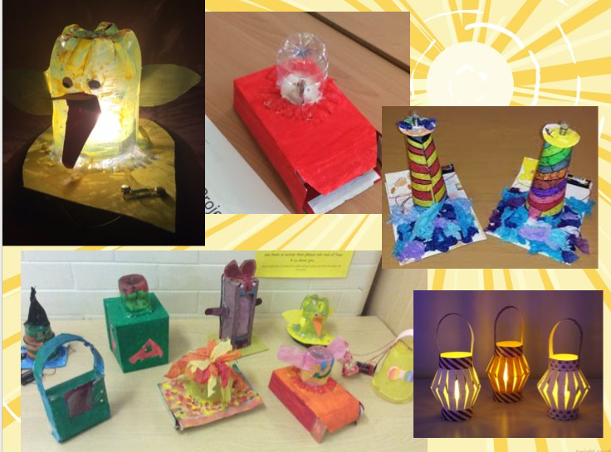

Symbols for switches in electrical diagrams

